A PROJECT REPORT

ON

# “Laser”

Submitted in the partial fulfillment of the requirements for The degree of

**BACHELOR OF ENGINEERING IN COMPUTER ENGINEERING**

**By**

1. Adnan Shaikh

2. Zeeshan Ansari

3. Binitdev Pandey

4. Kanchan Mengune



DEPARTMENT OF COMPUTER ENGINEERING SARASWATI COLLEGE OF ENGINEERING, SECTOR-5, KHARGHAR, NAVI MUMBAI-410210

UNIVERSITY OF MUMBAI

**ACADEMIC YEAR 2020**



**CERTIFICATE**

*This is to certify that the requirements for the mini-project report entitled ” ” have been successfully completed by the following students:*

Roll no Names

55 Adnan Shaikh

40 Binitdev Pandey

33 Kanchan Mengune

03 Zeeshan Ansari

In partial fulfillment of Sem –III, **Bachelor of Engineering in Computer Engineering,** Saraswati college of Engineering, Kharghar, **University of Mumbai,** during the academic year 2020

Internal Guide

(Prof. Hemalata Gosavi)

# Saraswati College of Engineering, Kharghar

### Vision:

To be universally accepted as autonomous center of learning in Engineering Education and Research .

**Mission:**

* To educate students to become responsible and quality technocrats to fulfill society and industry needs .
* To nurture students creativity and skill for taking up challenges in all facets of life.

**Department of Computer Engineering**

**Vision:**

To be among renowned institution in computer engineering education and research by developing globally competent graduates

**Mission:**

* To produce quality Engineering graduates by imparting quality training, hands on experience and value education.
* To pursue research and new technologies in Computer Engineering and across interdisciplinary areas that extends the scope of Computer Engineering and benefit humanity.
* To provide stimulating learning ambience to enhance innovative ideas, problem solving ability, leadership qualities, team-spirit and ethical responsibilities.



**DEPARTMENT OF COMPUTER ENGINEERING**

**PROGRAM EDUCATIONAL OBJECTIVE’s**

1. To embed a strong foundation of Computer Engineering fundamentals to identify, solve, analyze and design real time engineering problems as a professional or entrepreneur for the benefit of society.
2. To motivate and prepare students for lifelong learning & research to manifest global competitiveness.
3. To equip students with communication, teamwork and leadership skills to accept challenges in all the facets of life ethically.



**DEPARTMENT OF COMPUTER ENGINEERING PROGRAM OUTCOMES**

1. **Apply the knowledge of Mathematics, Science and Engineering Fundamentals to solve complex Computer Engineering Problems.**
2. **Identify, formulate and analyze Computer Engineering Problems and derive conclusion using First Principle of Mathematics, Engineering Science and Computer Science.**
3. **Investigate Complex Computer Engineering problems to find appropriate solution leading to valid conclusion.**
4. **Design a software System, components, Process to meet specified needs with appropriate attention to health and Safety Standards, Environmental and Societal Considerations.**
5. **Create, select and apply appropriate techniques, resources and advance engineering software to analyze tools and design for Computer Engineering Problems.**
6. **Understand the Impact of Computer Engineering solution on society and environment for Sustainable development.**
7. **Understand Societal, health, Safety, cultural, Legal issues and Responsibilities relevant to Engineering Profession.**
8. **Apply Professional ethics, accountability and equity in Engineering Profession.**
9. **Work effectively as a member and leader in multidisciplinary team for a common goal.**
10. **Communicate effectively within a Profession and Society at large.**
11. **Appropriately incorporate principles of Management and Finance in one’s own Work.**
12. **Identify educational needs and engage in lifelong learning in a Changing World of Technology.**



**DEPARTMENT OF COMPUTER ENGINEERING PROGRAMME SPECIFIC OUTCOME (PSO)**

1. **Formulate and analyze complex engineering problems in computer engineering (Networking/Big data/ Intelligent Systems/Cloud Computing/Real time systems)**
2. **Plan and develop efficient, reliable and secure system and customized application software using cost effective emerging software tools ethically**

**Project Title ABSTRACT**

The Laser Animation is a motion graphic created by using simple drawing shapes on the screen in fix interval of times which makes the object on the screen appear moving or in action. This project key is flood fill algorithm, moveto() and lineto() function.

Keywords : Animations, set action

## Table of Content

CHAPTER NO. TITLE PAGE NO.

* 1. **INTRODUCTION 9**
  2. **HARDWARE SOFTWARE REQUIREMENT 10**
  3. **DETAILED DESIGN 11-21**
  4. **SCREENSHOTS OF PROJECT 23-26**
  5. **CONCLUSION 27**

**CHAPTER 1**

**INTRODUCTION**

**Computer Graphics:**

Computer Graphics is the discipline of generating images with the aid of computer. Today,

Computer graphics is the core in the field of digital photography, video games, animations,

Cell phones, graphics of computer display.

**Applications of Computer Graphics:**

1. Art and Commerce
2. Scientific Analysis
3. Education and training
4. Animation and Image Processing

Here in the mini project that is “**Laser**” we have demonstrated the use of computer graphics which can be good example of videography and image processing.

**CHAPTER 2**

**HARDWARE AND SOFTWARE REQUIREMENTS**

**Minimum Hardware Required:**

1. Pentium IV and above.
2. 2 GB of RAM.
3. 1 GB Hard disk space.
4. Keyboard and mouse.

**Software Required:**

Turbo C3 for Graphic Coding

**CHAPTER 3**

**DETAILED DESIGN**

**Designed Code:**

***Program:***

#include<stdio.h>

#include<conio.h>

#include<graphics.h>

#include<dos.h>

// FUNCTIONS USED

void projectwork1();

void projectwork2();

void projectwork3();

void closing();

void main()

{

int gd=DETECT,gm,x,y;

initgraph(&gd,&gm,"c:\\turboc3\\bgi"); //Initializing Graphics Mode

projectwork1();

projectwork2();

projectwork3();

closing();

getch();

closegraph();

restorecrtmode();

}

void projectwork1() // AMPLIFICATION

{

setbkcolor(BLUE);

setcolor(WHITE);

circle(170,230,8);

setfillstyle(1,YELLOW);

floodfill(170,230,WHITE);

setcolor(GREEN);

settextstyle(11,0,2);

outtextxy(150,250,"PHOTON");

delay(2000);

settextstyle(7,0,4);

setcolor(WHITE);

outtextxy(110,380,"Amplification of Photons");

delay(1000);

setcolor(WHITE);

circle(250,180,8); //SECOND_UP

circle(250,280,8);

floodfill(250,180,WHITE);

floodfill(250,280,WHITE);

delay(500);

circle(330,120,8); //THIRD_UP

circle(330,195,8);

circle(330,265,8);

circle(330,340,8); //THIRD_DOWN

floodfill(330,120,WHITE);

floodfill(330,195,WHITE);

floodfill(330,265,WHITE);

floodfill(330,340,WHITE);

delay(500);

circle(410,80,8);

circle(410,125,8);

circle(410,165,8);

circle(410,210,8);

circle(410,245,8);

circle(410,285,8);

circle(410,325,8);

circle(410,370,8);

floodfill(410,80,WHITE);

floodfill(410,125,WHITE);

floodfill(410,165,WHITE);

floodfill(410,210,WHITE);

floodfill(410,245,WHITE);

floodfill(410,285,WHITE);

floodfill(410,325,WHITE);

floodfill(410,370,WHITE);

delay(3000);

cleardevice();

}

void projectwork2()

{

setbkcolor(BLUE);

setcolor(WHITE);

setfillstyle(1,RED); // ATOM

circle(310,230,30);

floodfill(310,230,WHITE);

setcolor(YELLOW);

settextstyle(11,0,2);

outtextxy(296,270,"ATOM");

setcolor(WHITE);

setfillstyle(1,GREEN); // PHOTON

circle(190,110,5);

floodfill(190,110,WHITE);

setcolor(GREEN);

outtextxy(170,120,"PHOTON");

delay(2000);

setcolor(BLUE);

outtextxy(170,120,"PHOTON");

setfillstyle(1,BLACK);

floodfill(190,110,WHITE);

setcolor(BLACK);

circle(190,110,5);

setcolor(WHITE);

circle(210,130,5);

setfillstyle(1,GREEN);

floodfill(210,130,WHITE);

delay(300);

setfillstyle(1,BLACK);

floodfill(210,130,WHITE);

setcolor(BLACK);

circle(210,130,5);

setcolor(WHITE);

circle(230,150,5);

setfillstyle(1,GREEN);

floodfill(230,150,WHITE);

delay(300);

setfillstyle(1,BLACK);

floodfill(230,150,WHITE);

setcolor(BLACK);

circle(230,150,5);

setcolor(WHITE);

circle(250,170,5);

setfillstyle(1,GREEN);

floodfill(250,170,WHITE);

delay(300);

setfillstyle(1,BLACK);

floodfill(250,170,WHITE);

setcolor(BLACK);

circle(250,170,5);

setcolor(WHITE);

circle(270,190,5);

setfillstyle(1,GREEN);

floodfill(270,190,WHITE);

delay(300);

setfillstyle(1,BLACK);

floodfill(270,190,WHITE);

setcolor(BLACK);

circle(270,190,5);

setcolor(WHITE);

circle(295,215,5);

setfillstyle(1,GREEN);

floodfill(295,215,WHITE);

delay(300);

setfillstyle(1,RED);

floodfill(295,215,WHITE);

setcolor(RED);

circle(295,215,5);

setcolor(WHITE);

setfillstyle(1,YELLOW); // ATOM

circle(310,230,30);

floodfill(310,230,WHITE);

setcolor(YELLOW);

settextstyle(7,0,3);

outtextxy(115,50,"Stimulation of ATOM to Release Photons");

setcolor(WHITE);

delay(300);

setfillstyle(1,RED); // ATOM

circle(310,230,30);

floodfill(310,230,WHITE);

setcolor(WHITE);

circle(346,225,5);

setfillstyle(1,GREEN);

floodfill(346,225,WHITE);

circle(346,235,5);

floodfill(346,235,WHITE);

delay(800);

setfillstyle(1,BLACK);

floodfill(346,225,WHITE);

floodfill(346,235,WHITE);

setcolor(BLACK);

circle(346,225,5);

circle(346,235,5);

setcolor(WHITE);

circle(365,205,5);

setfillstyle(1,GREEN);

floodfill(365,205,WHITE);

circle(365,255,5);

floodfill(365,255,WHITE);

delay(300);

setfillstyle(1,BLACK);

floodfill(365,205,WHITE);

floodfill(365,255,WHITE);

setcolor(BLACK);

circle(365,205,5);

circle(365,255,5);

setcolor(WHITE);

circle(385,185,5);

setfillstyle(1,GREEN);

floodfill(385,185,WHITE);

circle(385,275,5);

floodfill(385,275,WHITE);

delay(300);

setfillstyle(1,BLACK);

floodfill(385,185,WHITE);

floodfill(385,275,WHITE);

setcolor(BLACK);

circle(385,185,5);

circle(385,275,5);

setcolor(WHITE);

circle(405,165,5);

setfillstyle(1,GREEN);

floodfill(405,165,WHITE);

circle(405,295,5);

floodfill(405,295,WHITE);

delay(300);

setfillstyle(1,BLACK);

floodfill(405,165,WHITE);

floodfill(405,295,WHITE);

setcolor(BLACK);

circle(405,165,5);

circle(405,295,5);

setcolor(WHITE);

circle(425,145,5);

setfillstyle(1,GREEN);

floodfill(425,145,WHITE);

circle(425,315,5);

floodfill(425,315,WHITE);

delay(300);

setfillstyle(1,BLACK);

floodfill(425,145,WHITE);

floodfill(425,315,WHITE);

setcolor(BLACK);

circle(425,145,5);

circle(425,315,5);

setcolor(WHITE);

circle(445,125,5);

setfillstyle(1,GREEN);

floodfill(445,125,WHITE);

circle(445,335,5);

floodfill(445,335,WHITE);

delay(300);

setfillstyle(1,BLACK);

floodfill(445,125,WHITE);

floodfill(445,335,WHITE);

setcolor(BLACK);

circle(445,125,5);

circle(445,335,5);

setcolor(WHITE);

circle(465,105,5);

setfillstyle(1,GREEN);

floodfill(465,105,WHITE);

circle(465,355,5);

floodfill(465,355,WHITE);

delay(300);

setfillstyle(1,BLACK);

floodfill(465,105,WHITE);

floodfill(465,355,WHITE);

setcolor(BLACK);

circle(465,105,5);

circle(465,355,5);

setcolor(WHITE);

circle(485,95,5);

setfillstyle(1,GREEN);

floodfill(485,95,WHITE);

circle(485,375,5);

floodfill(485,375,WHITE);

circle(190,110,5);

floodfill(190,110,WHITE);

setcolor(YELLOW);

settextstyle(11,0,2);

outtextxy(170,120,"PHOTON");

outtextxy(465,110,"PHOTON");

outtextxy(465,390,"PHOTON");

delay(5000);

cleardevice();

}

void projectwork3()

{

setbkcolor(BLACK);

setcolor(WHITE);

rectangle(200,150,460,160);

rectangle(200,300,460,310);

setfillstyle(1,GREEN);

floodfill(250,155,WHITE);

floodfill(250,305,WHITE);

ellipse(200,230,90,89,15,70); //MIRROR

setfillstyle(1,BLUE);

floodfill(205,232,WHITE);

ellipse(460,230,90,89,15,70); // SEMI SILVERED MIRROR

setfillstyle(1,CYAN);

floodfill(465,232,WHITE);

rectangle(300,365,360,380); // POWER SOURCE

setfillstyle(1,RED);

floodfill(305,370,WHITE);

moveto(300,365);

lineto(310,355);

lineto(370,355);

lineto(360,365);

moveto(360,380);

lineto(370,370);

lineto(370,355);

floodfill(305,362,WHITE);

floodfill(366,370,WHITE);

setcolor(YELLOW);

settextstyle(11,0,2);

outtextxy(288,390,"POWER SOURCE");

outtextxy(300,120,"ELECTRODES");

outtextxy(130,230,"MIRROR");

outtextxy(480,175,"SEMI SILVERED");

outtextxy(510,190,"MIRROR");

setcolor(WHITE);

moveto(370,363);

lineto(411,363);

lineto(411,265);

moveto(370,366);

lineto(413,366);

lineto(413,265);

rectangle(395,260,428,265);

floodfill(396,261,WHITE);

rectangle(395,200,428,205);

floodfill(396,201,WHITE);

rectangle(240,260,273,265);

floodfill(241,261,WHITE);

rectangle(240,200,273,205);

floodfill(241,201,WHITE);

moveto(255,265);

lineto(255,376);

lineto(300,376);

moveto(257,265);

lineto(257,373);

lineto(300,373);

setcolor(RED);

moveto(280,205);

lineto(280,260);

lineto(273,260);

moveto(273,205);

lineto(280,205);

moveto(435,205);

lineto(435,260);

lineto(428,260);

moveto(428,205);

lineto(435,205);

setcolor(WHITE);

circle(100,50,8);

setfillstyle(1,RED);

floodfill(100,50,WHITE);

circle(100,85,3);

setfillstyle(1,YELLOW);

floodfill(100,85,WHITE);

setcolor(YELLOW);

outtextxy(128,47,"ATOM");

outtextxy(128,82,"PHOTON");

// ATOM AND PHOTON MOVEMENT

setcolor(WHITE);

setfillstyle(1,RED); //ATOM

circle(365,205,8);

floodfill(365,205,WHITE);

circle(325,285,8);

floodfill(325,285,WHITE);

delay(3000);

circle(325,260,8);

floodfill(325,260,WHITE);

setfillstyle(1,BLACK);

floodfill(325,285,WHITE);

setcolor(BLACK);

circle(325,285,8);

setcolor(WHITE);

setfillstyle(1,RED);

circle(345,190,8);

floodfill(345,190,WHITE);

setfillstyle(1,BLACK);

floodfill(365,205,WHITE);

setcolor(BLACK);

circle(365,205,8);

delay(500);

setfillstyle(1,RED);

setcolor(WHITE);

circle(325,170,8);

floodfill(325,170,WHITE);

setfillstyle(1,BLACK);

floodfill(345,190,WHITE);

setcolor(BLACK);

circle(345,190,8);

setcolor(WHITE);

setfillstyle(1,YELLOW);

circle(250,250,3);

floodfill(250,250,WHITE);

delay(100);

circle(275,225,3);

floodfill(275,225,WHITE);

delay(100);

circle(295,205,3);

floodfill(295,205,WHITE);

delay(100);

circle(315,185,3);

floodfill(315,185,WHITE);

delay(100);

circle(320,205,3);

floodfill(320,205,WHITE);

delay(100);

circle(345,205,3);

floodfill(345,205,WHITE);

circle(365,205,3);

floodfill(365,205,WHITE);

delay(100);

circle(385,210,3);

floodfill(385,210,WHITE);

circle(395,220,3);

floodfill(395,220,WHITE);

circle(305,225,3);

floodfill(305,225,WHITE);

circle(325,245,3);

floodfill(325,245,WHITE);

delay(100);

circle(345,265,3);

floodfill(345,265,WHITE);

delay(100);

circle(345,235,3);

floodfill(345,235,WHITE);

delay(100);

circle(365,285,3);

floodfill(365,285,WHITE);

circle(365,230,3);

floodfill(365,230,WHITE);

delay(100);

circle(395,245,3);

floodfill(395,245,WHITE);

delay(100);

circle(415,225,3);

floodfill(415,225,WHITE);

delay(100);

circle(425,245,3);

floodfill(425,245,WHITE);

delay(300);

setlinestyle(SOLID_LINE,1,3);

setcolor(YELLOW);

moveto(460,230);

lineto(600,230); //LASER

setcolor(YELLOW);

outtextxy(510,240,"LASER");

moveto(540,230);

lineto(535,225);

moveto(540,230);

lineto(535,235);

delay(3000);

cleardevice();

}

void closing()

{

setbkcolor(RED);

setcolor(YELLOW);

settextstyle(7,HORIZ_DIR,4);

outtextxy(160,180,"!! THANK YOU !!");

outtextxy(120,280," Press any key to EXIT");

}

**CHAPTER 4**

**OUTPUT SCREENSHOT**

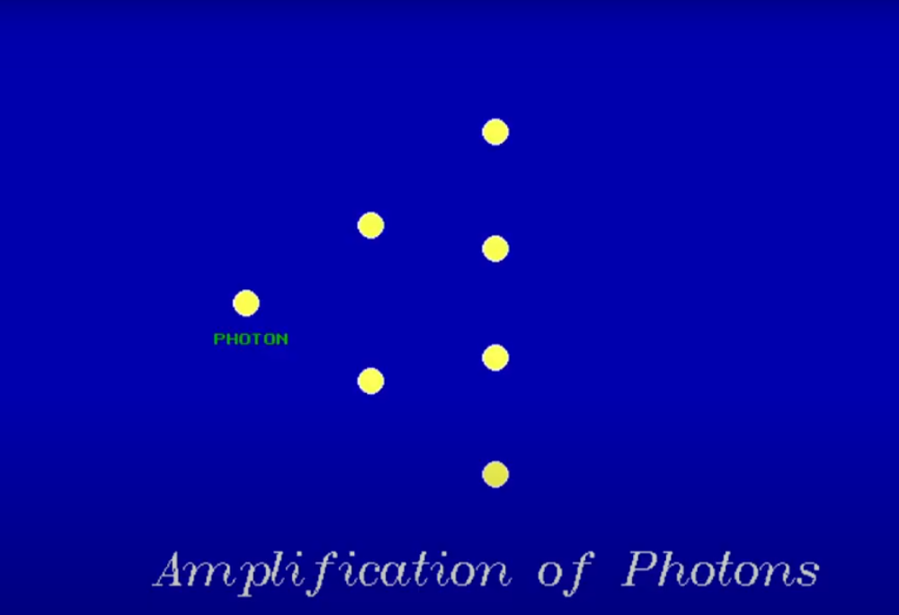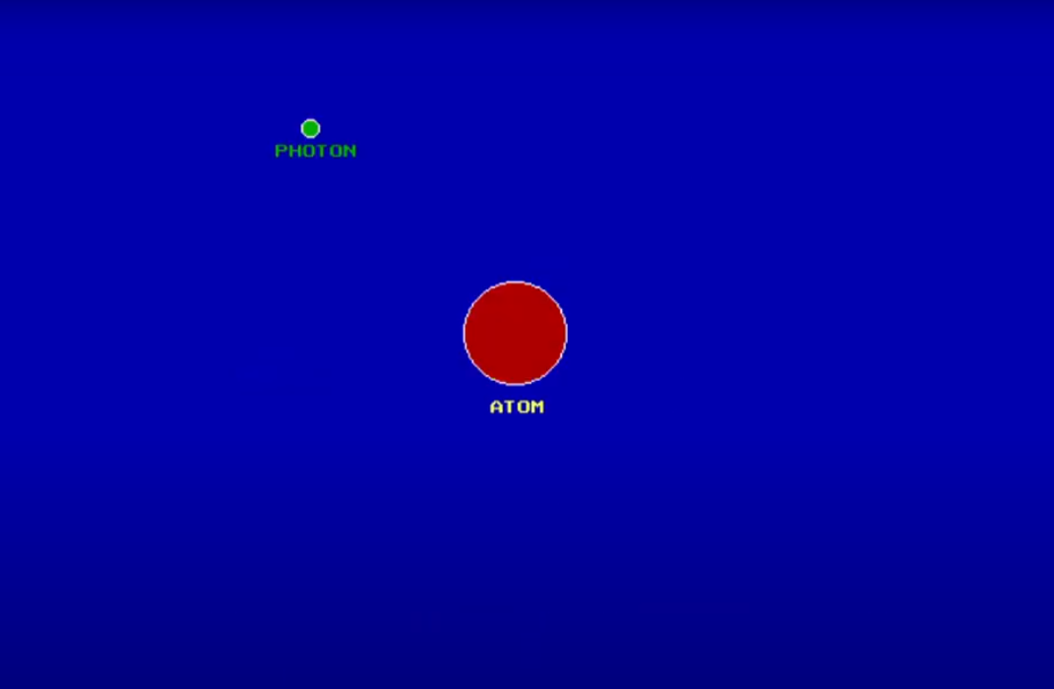

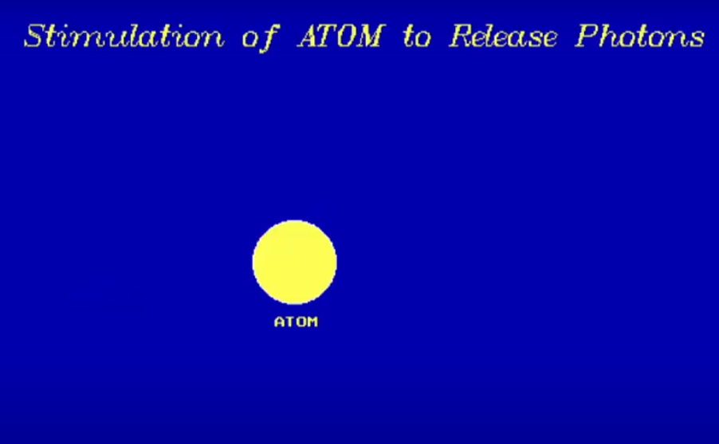

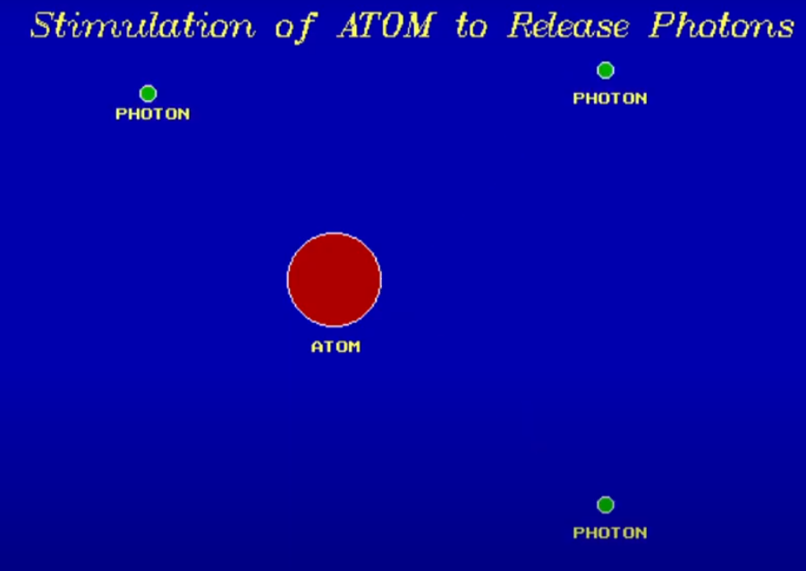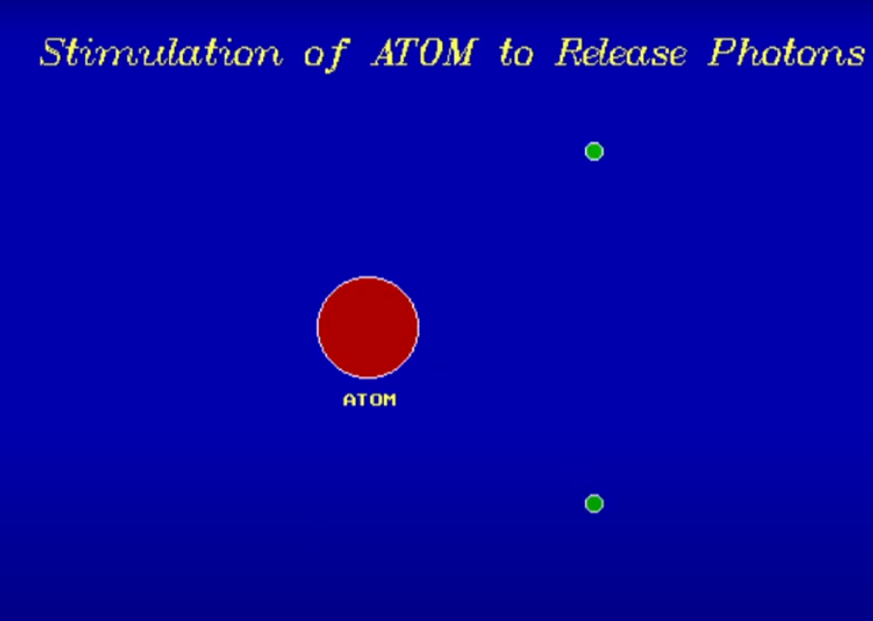

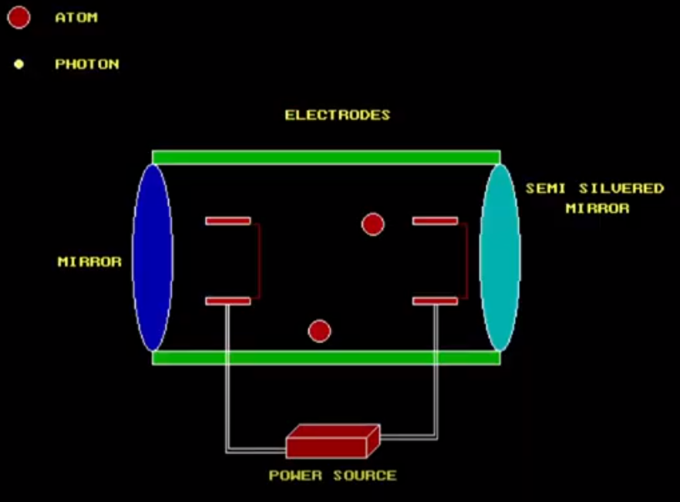

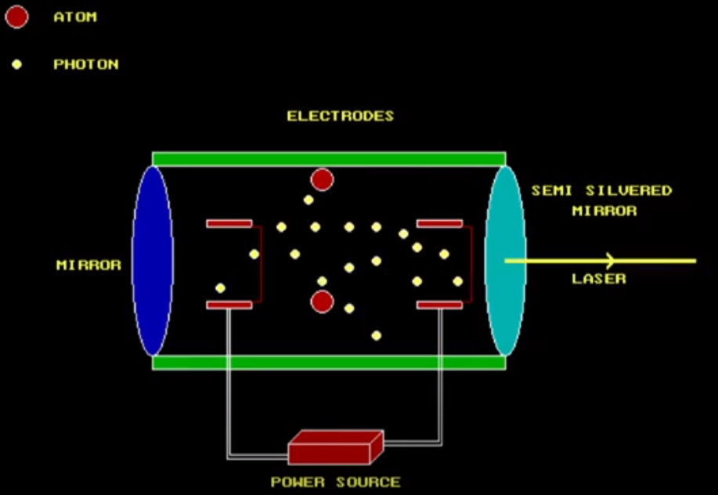

**CHAPTER 5**

**CONCLUSION**

Thus we studied Computer Graphics with help of this mini project. Thus by using similar logic we can design more animation and motion graphics.